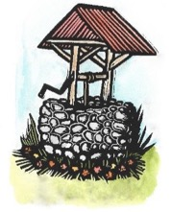
VISIONS
FOR CREATIVE HOUSING SOLUTIONS, INC.

2017 ANNUAL REPORT

The mission of Visions for Creative Housing Solutions, Inc. is to provide residential options, services, and supports designed to meet the needs of adults with special needs.
Visions fosters growth and independence through vocational, social and recreational opportunities at Sunrise Farm, Enfield, NH. Visions is assisting individuals with special needs to lead rich and full lives as productive members of the community.
Financial Snapshot  Gross Revenues rose from $419,000 in 2016 to approximately $539,000 in 2017.  Total expenses rose from $391,600 in 2016 to approximately $462,000 in 2017. | Support & Revenue  Approximately 130 donors contributed over $40,000 in individual contributions during 2017.  Visions is also supported by Granite United Way, and Grafton County Board of Commissioners.
Our Work  - Provide a safe, attractive living environment  - Focus on private and social space  - Collaborative cooking, preparing healthy meals  - Support with daily living tasks  - Transportation, public and private  - Social opportunities  - Assistance with devising personal goals for each resident  - Support with finding and maintaining employment and volunteer opportunities | Our Philosophy  - Facilitate community opportunities for work, continuing education and social activities  - Sustain long term relationships and friendships  - Provide personal choices  - Offer a permanent residence that provides opportunity for personal growth and independence  - Facilitate an inclusive environment within our community  - Enable our adult children with disabilities to develop a separate life for themselves, making relationships and connections of their own

2017 Highlights | 2018 Goals
Visions, Sunrise Farm, is fully occupied with 10 residents and one open bed used for respite care.  Visions has 16 full and part-time staff that support our residents and our organizational needs.  Visions replaced the septic system with assistance from the Community Home Loan Fund of NH for $32,000  NH Housing Finance Authority awarded Visions $50,000 as an Emerging Opportunities grant to be used to increase our models throughout the state. | Visions has an agreement with Twin Pines Housing Authority to use 4 apartments in their new Tracy Street Development in West Lebanon to be opened Spring 2019.  Visions is investigating the purchase of property on 12 Green Street Lebanon to support up to ten individuals.  Visions is in the process of writing grants to do much needed work at Sunrise Farm to renovate the buildings, make them more cost effective and energy efficient. A formal needs assessment was made possible through a grant awarded by the NH Community Development Finance Authority.

Stories of Us
Two new residents moved into Visions in 2017, making our total at Sunrise Farm 10 individuals. Two of our residents moved in the fall from Sunrise Farm in Enfield to their own apartment in Lebanon with plans to get married in August. Visions continues to support the young couple with outreach services provided by Visions staff.  100% of Visions residents received supports to be employed at various locations in the Upper Valley. All of our residents volunteer in the community.  Visions provided four individuals with regular respite support. Giving individuals a social experience and their families or support providers a break from their routine. | 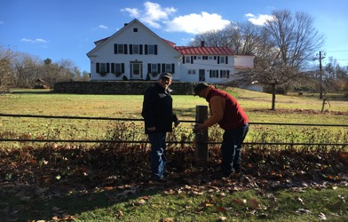

Our Residents Giving Back
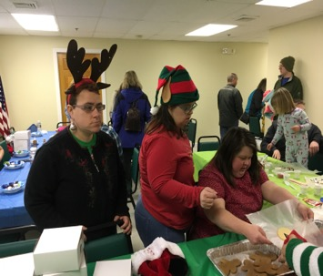 | Visions has made a commitment that our residents give back to our community. Last year our residents volunteered approximately 860 hours in such locations as the Enfield Police Department, Upper Valley Humane Society, SAU 62, Enfield Town Office, Senior Assistance and Special events including Home Town for the Holidays, the Shaker 7 Race, and Green-up Day.

Visions Staff
Visions has a dedicated staff of 12 direct support mentors who work individually with our 10 residents as needed, as well as with multiple residents as appropriate. It is their commitment to Visions and our residents that we are proud to acknowledge. Visions administrative staff is comprised of the Executive Director, a House Manager, a Nurse Manager and an Administrative Assistant.

Visions Volunteers
We have over 25 wonderful volunteers who came to Visions in 2017. They help us with cleaning and organizing, sewing projects with the residents, cooking meals and keeping our donation list up to date. They help with special events and projects.  Approximately 600 hours were volunteered in 2017, with a weekly average of 10 hours. Thank you to Hypertherm for volunteering on special projects over the course of the year.  The volunteers give so much to us and we are told by them how much their volunteering here enriches their lives. | 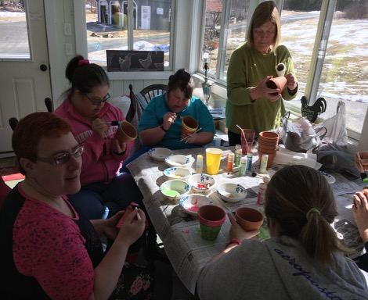

Thank you to our Donors and Supporters. You help us to carry out our mission in supporting individuals with special needs living a full and rich life.

Special thanks to the Byrne Foundation, Granite United Way and Grafton County Commission.

Thank you to 2017 Visions Board of Directors

Carol Andrew, President Members at Large:
David Dow, Vice President Adam Ricker Lyndsay Porreca
Fred Williamson, Treasurer Scott Gilmore Carl Thum
Elizabeth Larsen, Secretary Pam Blair Terry Dorr

In 2017 we had our first sustaining member supporting our mission. If you are interested in becoming a sustaining member with a monthly contribution to Visions to help support our operating costs, please contact us.

Visions for Creative Housing Solutions, Inc.
Sylvia Dow, Executive Director
8 Sunrise Farm Lane
Enfield, NH. 03748
603-632-7707
vfchsorg@gmail.com
www.visionsnh.org

