Excerpt from:
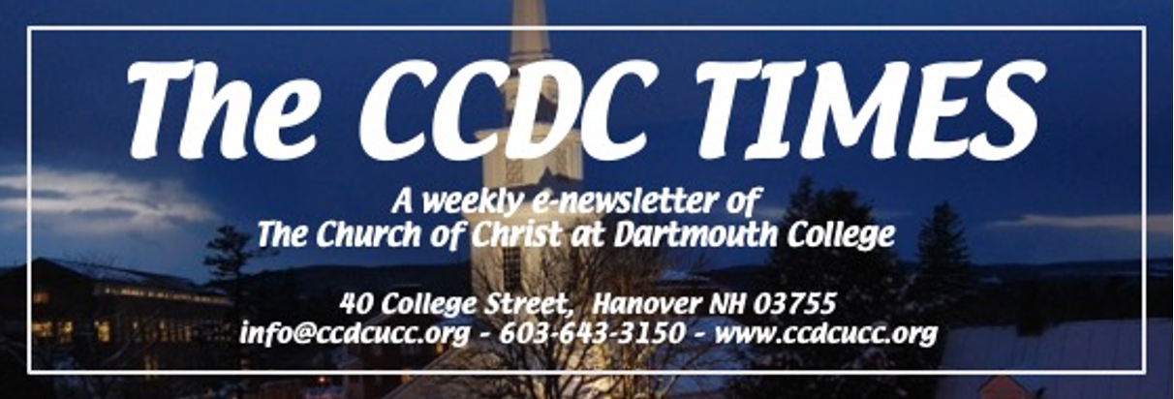

MAY 26, 2022

Outreach House Gets a New Vision
Outreach House, a nonprofit offering supported housing for seniors, opened its doors at 11 S. Park Street in April of 1997, thanks to the volunteer efforts of Ann James and several other members of our congregation. For years, it served as a warm, safe haven for elders - but because it began as a residential home, it proved difficult to use adaptive equipment and to fit all of the necessary aids needed to ensure safe accessibility throughout. When in June of 2019 Outreach House could no longer afford the rising cost of supporting its residents, it donated the property to Visions for Creative Housing Solutions so its mission of offering supported housing would continue.
Considering the rich and longstanding connection CCDC has had to Outreach House and our recent Russell Fund support of Visions, we wanted to alert the congregation to the fact that the building is coming down early next week. Many of us will no doubt be feeling nostalgic but it's an exciting next step to address a dire need for a population that is chronically underserved.
To refresh our collective memories, Visions Hanover will be a fully wheelchair accessible site providing permanent, supported housing for 12 individuals with developmental disabilities. The new building will be an ADA compliant, energy efficient residence that will include: six 1-bed, two 2-bed, and one 3-bed apartments; a large kitchen and dining room for family-style dinners, space for administrative offices, and accommodations for overnight staffing. As is the case at their "homes" in Enfield and Lebanon, the environment will be conducive to long term friendships and a sense of well-being and self-worth. Private as well as shared social space, healthy meals cooked collaboratively, support with daily living, vocational coaching, and transportation to jobs and service in the community are all part of life at Visions.
Construction on the new building is expected to begin before the end of the year with the hope of opening early 2024.
Our new neighbors will no doubt contribute to the community in deeply meaningful ways and it's a privilege for CCDC to play a small part in assuring the reality of a Visions property in Hanover. Stay tuned for general updates and opportunities to engage as the project develops.
The Board of Outreach

